TITLE GOES HERE USING TIMES ROMAN BOLD CAPITAL LETTERS - MAXIMUM 14 WORDS, CENTRED

O.N.E. Writer¹, A.N. Other² and N.R. Three¹

¹Unit for Microscopy, University of Abracadabra, Pretoria, ²Dept. of Anatomy, University of Marvelloussy, Krakatoa

The following document template may be used to write your abstract with before submission using the online abstract submission system. Although the online system will automatically format the inserted text, figures and tables it is advised to prepare your abstract using this template to avoid unnecessary delays related to the adherence of abstract requirements.

Detailed instructions related to online submission may be found in the step-by-step guide available for download on the abstract submission form.

The following document formatting rules apply. The abstract should be prepared to fit on one A4 page, with a total printed area that is 260mm high and 170mm wide.

The body of the text is formatted in two columns, each a maximum of 235mm high, by 80mm wide. Margins should be 20mm on the left and right hand sides of the page, with 10mm spacing between the two columns. The top and bottom margins are both set at 17mm.The font used throughout the abstract should be Times Roman font at 10pt size, spaced at 6 lines per inch.

The title should be descriptive, in bold capitals, contain a maximum of 14 words, and be centered. Species’ names should be in lower case bold italics (not italicized capitals). No full stop at the end of the title. A blank line should be entered after the title.

The author/s names are in lower case, centered, and followed by another blank line, after which the author/s affiliations appear in lower case, centered. Abbreviated addresses may be used, so that the affiliations do not normally occupy more than one line. No punctuation marks appear after both the author and the affiliation lines. The e-mail address of the corresponding author appears at the foot of the right hand column.

The body of the abstract should begin after another blank line and should contain not less than 350 words. Paragraphs are not indented or numbered, are without headings and are separated by a blank line.

Please ensure that the abstract follows the scientific format of introduction, materials and methods, results, discussion and conclusion. The text should describe the aim of the work and should provide a brief introduction, sufficient to orientate the non-specialist reader. A brief description of the techniques employed, a discussion of the results, and a mention of the most important conclusions should follow this.

The left hand column should contain text only; the right hand column may contain text, and/or tables and/or figures and references. A combined maximum of 3 tables and figures are allowed.

All figures or tables should be referred to in the text (eg. Fig. 1), should have brief but clear captions, and should be provided with a scale bar if relevant, the dimensions of which may be defined either in the figure or in the caption. Tables should be uploaded as an image during online submission and can be labelled by the system accordingly.

Before inserting an image, it is strongly advised that it be sized to 80mm wide, at a final resolution of approximately 300dpi, and saved in JPG format. This formatting can be done in most graphics software packages. Please ensure to maintain the correct aspect ratio of images when resizing. Inserted image file size may not exceed 1MB.

Please feel free to contact the editor-in-chief if the above requirements are onerous in any specific case. The above size constraints are suggested in the interests of limiting the required e-mail bandwidth.

Literature citations are by means of superscript numbers¹.

Literature references should follow one double space below the text under the heading “References”. For four or more authors, use the first author followed by et al.

References
1. Sato, T., Iwatsuki, M. and Tochihara, H. (1999) J. Electron Microsc. 48(1), 1. (for a journal citation)
2. Meek, G.A. (1970) Practical Electron Microscopy for Biologists. London, Wiley-Interscience. (for a book citation)
3. Other, A.N. (2000) Proc. Microsc. Soc. South. Afr. 30, 222. (for a proceedings citation)

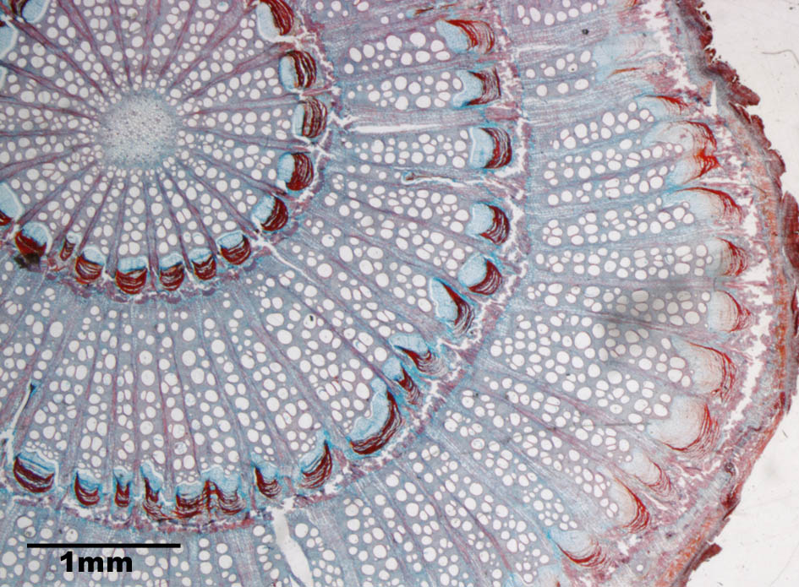
Figure 1. Transverse section of a liana stem with concentric rings of vascular bundles.

Corresponding author: writer.o@umic.ac.za

